


Name ……………………………………

Date ……………………………………..

Writing a letter

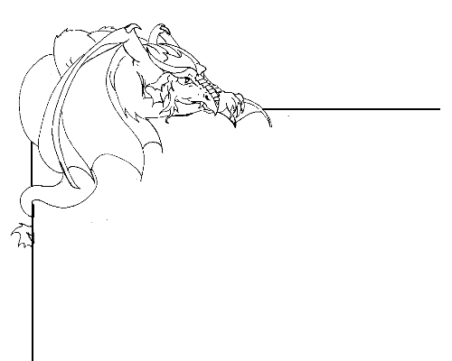

Informal letter writing

A letter is a written message from one person, addressed to another person or group of people. There are various types of letter. Informal letters often contain news about the person writing the letter. Formal letters are sent to organisations and may, for example, be a letter of complaint or an enquiry.

You can write two types of letter in this exercise.
- A letter from home or school to someone in Dragonsville, or
- A letter from yourself somewhere in Dragonsville, back to your home or school.

Decide which type of letter you would like to write.

Who are you going to write to? A particular dragon, a friend, your family?

What are you going to write about? Are you going to ask a question or explain something that you have been doing?

Is there a topic that you would like to write about?
…………………………………………………………………………………………………….
Once you have thought about these questions you can begin to write an informal letter.

Begin with your address in the top right hand corner of the page. Remember, if you are submitting your letter to Kids on the Net, you will not be asked for your last name or address.

Below the address, across on the left side of the page write ‘Dear [the name of the person you are writing to],

Now you can write your letter. Remember;
  - Make your writing clear so that the person reading the letter can understand what you are writing about.
  - Keep it short. Be concise and straight to the point with what you are saying.
  - If you write about a topic, finish writing about that topic before you start to write about something else.
  - Be polite and courteous. Words can come across very harsh when written on paper.
  - Make sure your spelling, punctuation and grammar is correct and clear so that the reader can understand what you are writing about.
  - Use a line guide to help you stay neat.

Dragonsville Letter

Send your letter to Dragonsville by typing it into the web forms at
http://kotn.ntu.ac.uk/dragonsville/letterform.htm or http://kotn.ntu.ac.uk/dragonsville/letterout.htm

